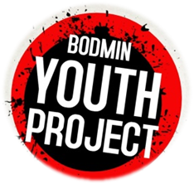**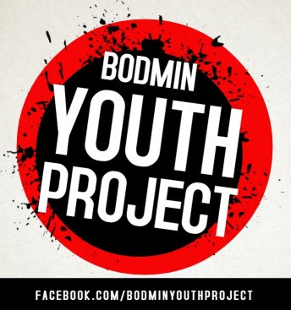COMMUNITY FOOTBALL/ GAMES SESSIONS**

[www.bodminyouthproject.org](http://www.bodminyouthproject.org)

**Registration Form**

**Please email to** [**bodminyouthproject@outlook.com**](mailto:bodminyouthproject@outlook.com) **to book or bring this form to confirm your child’s place. NB. Your child will need to have consent to take part.**

Please tick the relevant sessions your child would like to attend:

**Fair Park (Ages 10-17s)** 1 May ___; 15 May ____;  **H/T EVENT TBC 29 May ____;**

5 June ____ ; 19 June ____ ; 3 July ____ ; 17 July ____

**DETAILS OF CHILD** (If more than one child then can add details on one form or in email)

|  |  |
| --- | --- |
| First Name | Last Name |
| DOB Age | Gender (male or female) |
| Any disabilities and/or medical condition? | |
| **PARENTAL CONSENT** | |
| I agree to my child having his/ her photo taken or being video-recorded for our website/ social media page and/or future publicity? YES / NO | |
| I agree to relevant email/ sms publicity being sent to me? YES / NO | |
| I agree that a coach/ youth leader may treat any injury which my child sustains whilst participating in the football/ activity session if required? YES / NO | |
| I agree for my child (under 16 years of age) to participate in the football/ activity sessions provided by the Bodmin Youth Project team of leaders YES / NO | |
| **I give consent for my child to sign in & out themselves, so they can walk home** **after the** **session** (If answer NO – please collect your child at end of session) **YES/ NO** | |

**CONTACT DETAILS**

|  |  |
| --- | --- |
| Name of parent/ guardian | |
| Address | |
| Postcode | Tel |
| Mobile | Email |
| Signature of parent/ guardian | Date  ______ / ________ / ________ |

Booking contact Steve Ovens (Youth Leader/ Coach) 07870 328 604 [bodminyouthproject@outlook.com](mailto:bodminyouthproject@outlook.com)