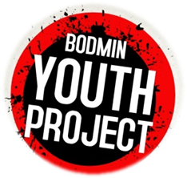
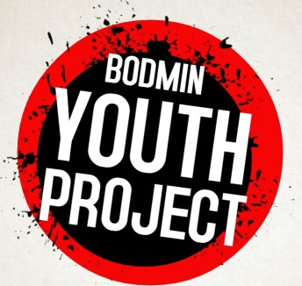
COMMUNITY FOOTBALL/ GAMES SESSIONS
www.bodminyouthproject.org
Registration Form
Please email to bodminyouthproject@outlook.com to book or bring this form to confirm your child’s place. NB. Your child will need to have consent to take part.
Please tick the relevant sessions your child would like to attend:
Fair Park (Ages 10-17s) 15 Jan ___; 29 Jan ____; 12 Feb _____ ;
H/T EVENT TBC ____; 26 Feb ____ ; 12 Mar ____ ; 26 Mar ____

DETAILS OF CHILD (If more than one child then can add details on one form or in email)
First Name | Last Name
DOB Age | Gender (male or female)
Any disabilities and/or medical condition?

PARENTAL CONSENT
I agree to my child having his/ her photo taken or being video-recorded for our website/ social media page and/or future publicity? YES / NO
I agree to relevant email/ sms publicity being sent to me? YES / NO
I agree that a coach/ youth leader may treat any injury which my child sustains whilst participating in the football/ activity session if required? YES / NO
I agree for my child (under 16 years of age) to participate in the football/ activity sessions provided by the Bodmin Youth Project team of leaders YES / NO
I give consent for my child to sign in & out themselves, so they can walk home after the session (If answer NO – please collect your child at end of session) YES/ NO

CONTACT DETAILS
Name of parent/ guardian
Address
Postcode | Tel
Mobile | Email
Signature of parent/ guardian | Date  ______ / ________ / ________

Booking contact Steve Ovens (Youth Leader/ Coach) 07870 328 604 bodminyouthproject@outlook.com

